Open Recruitment Day
- Turndown Attendants (part time) – Housekeeping
Student visas will only be considered for the Turndown position.
The Langham, Auckland -

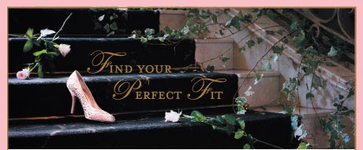

Open Recruitment Day
The Langham, Auckland is holding an open recruitment day on Friday 12th February from 10am - 2pm to recruit for various positions within the hotel.
If you want to work in an oasis of luxury with an engaged team, please come to the open day for walk-in interviews on Friday 12th February 2016 from 10am - 2pm in the Great Room (entrance off main entrance at 83 Symonds Street).
Please bring along your resume and proof of eligibility to work in New Zealand (e.g. visa, passport). Due to the volume of applicants we expect on the day, a recent photograph of yourself is welcomed.
Vacant Roles
- Food & Beverage Attendants (part time) - Eight Restaurant, In Room Dining & Banquets
- Bartender (part time) - Banquets
- Porters (part time) - Bell Desk
- Chef de Parties' (full time)- Kitchen
- Room Attendants (part time) - Housekeeping
- Turndown Attendants (part time) - Housekeeping
- Stewards (part time) - Stewarding
The Ideal Candidates will:
- Have experience in a similar role preferably in a 5 star luxury hotel environment
- Project a professional image at all times through personal presentation/interpersonal skills
- Strong communication skills
- Remain calm in high volume work situations with good time management skills
- Have the flexibility to work a rotating roster including weekends, evenings and public holidays
- In the kitchen area - candidates must have a food hygiene certificate
- In the Bell Desk - candidates must have a full clean New Zealand drivers license with the ability to drive both automatic and manual
- The legal right to work in New Zealand. Please note we require a minimum commitment on 1 year for all of our positions. Student visas will only be considered for the Turndown position.
About the Company
The Langham, Auckland is renowned for quality, timeless luxury and genuine service. Featuring 409 elegantly appointed guest rooms and suites, dining, meeting and function facilities, and the lavish haven –Chuan Spa .The Langham Auckland reflects Langham Hospitality Group's philosophy of elegance in design, innovation in hospitality, genuine service and captivation of the senses creating a uniquely enchanting experience.
Benefits
In return for your bespoke service to our guests, we will offer you a competitive salary with great development opportunities. We offer great benefits too - like free duty meals, uniform, free nights at our overseas and discounts on dining & accommodation.
For further information, please contact:
Human Resources - The Langham, Auckland
83 Symonds Street, Auckland
tlakl.recruitment@langhamhotels.com

